Metro Ticket Generating System
Requirement Analysis
User Stories, Data Flow & Solution Requirements

ServiceNow Platform | Version 1.0.0 | June 2026
Developed by Nithish Kanna

Introduction
This document captures the functional and non-functional requirements for the Metro Ticket Generating System. Requirements were elicited through stakeholder interviews, user story mapping, and data flow analysis.

Customer Journey
A commuter's journey with the system follows six stages: Awareness, Planning, Booking, Confirmation, Travel, and Completion. At each stage, the Service Portal replaces manual touchpoints with a digital self-service experience — from fare lookup to booking confirmation.

Data Flow Diagram
The Level 1 DFD below shows how data moves through the system. The commuter submits a booking request, the system validates input, calculates distance, looks up the fare matrix, computes the total fare, and records the transaction.
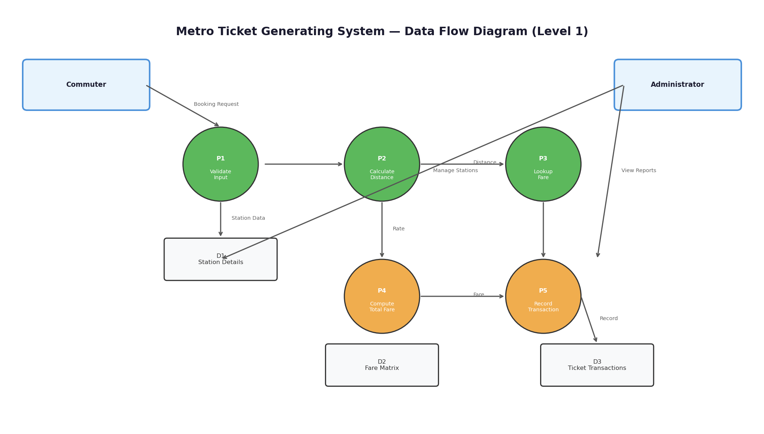
Figure 1: Data Flow Diagram — Level 1

User Stories
Ten user stories were defined covering commuter and administrator needs:
ID | Role | Story | Priority
US-01 | Commuter | Select start and destination stations from a dropdown | High
US-02 | Commuter | Enter number of tickets needed (1-10) | High
US-03 | Commuter | See calculated fare before confirming | High
US-04 | Commuter | Receive booking confirmation with transaction ID | Medium
US-05 | Admin | Add new stations to the system | High
US-06 | Admin | Update fare rates in the fare matrix | High
US-07 | Admin | View all ticket transactions with filters | Medium
US-08 | System | Prevent booking with same start and end station | High
US-09 | System | Calculate fare dynamically using fare matrix | High
US-10 | Commuter | Access booking portal on mobile devices | Medium

Functional Requirements
The system shall provide the following functional capabilities:
- Station Management — CRUD operations on station records (name, sequence number).
- Fare Matrix Management — CRUD on fare brackets (distance range, rate per stop).
- Ticket Booking — Select stations, enter quantity, view calculated fare.
- Dynamic Fare Calculation — Auto-calculate fare from distance and fare matrix.
- Input Validation — Prevent same-station selection and invalid quantities.
- Transaction Recording — Create a transaction record for each booking.
- Reference Display Override — Show station names instead of sys_id.
- Service Portal UI — Mobile-responsive booking form.
- Transaction Reporting — Filtered list views of all bookings.

Non-Functional Requirements
Category | Requirement | Target
Performance | Fare calculation response time | < 2 seconds
Performance | Concurrent user support | 50 users
Availability | System uptime | 99.9%
Usability | Mobile responsiveness | 320px+ screens
Security | Data access control | Role-based
Scalability | Station capacity | Up to 100 stations
Maintainability | Fare updates | No code changes needed
Audit | Transaction logging | All bookings with timestamp

Technology Stack
Platform:
ServiceNow Personal Developer Instance (PDI) — cloud-based application platform.
Backend:
Three custom tables (Station Details, Fare Matrix, Ticket Transactions) with reference relationships.
Business Logic:
Before Business Rule for dynamic fare calculation; onChange and onSubmit Client Scripts for validation.
User Interface:
Service Portal with Catalog Item widget, mobile-responsive layout.
Source Control:
ServiceNow Update Sets exported to Git repository.

